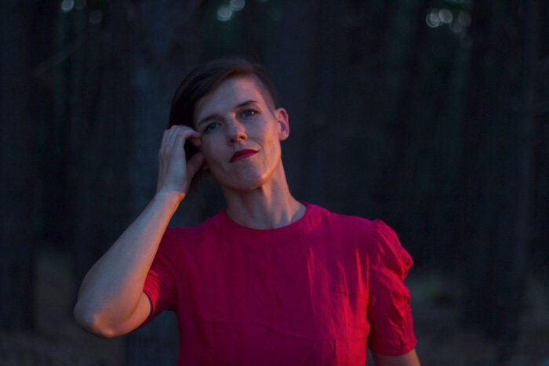
X A V I A
Live-looping multi-instrumentalist and NT Song of the year Finalist (2017 & 2018) XAVIA creates dreamy electronic-folk, a space to swoon in swirling strings, earthy rhythms and soaring melodies that draw you into a vivid song journey.
Her recent single HORIZONS, inspired by her desert home, invites listeners to ‘breathe in’ the vast landscape and has received international attention including JJJ airplay and over 700,000 Spotify streams in the 6 months following release. “Horizons was written while climbing desert mountains, drinking in the colour with thoughts ascending, heart exploding”.
Live, she is described as one of the most unique performers on the circuit, looping percussive cello, handmade beats and sparkling autoharp with evocative layered vocals.
XAVIA is originally from Adelaide, formally one half of sibling duo BrotherSister (triple j unearthed winners), and has lived and toured in Australia, Nashville and Europe as a cellist and session musician.
She is now based in the vibrant creative community of Alice Springs, performing interstate and across the NT including at the Darwin Festival, the Darwin Fringe Festival and Wide Open Space Festival with the likes of Kardajala Kirridalla, Haiku Hands, Resin Moon, Hiatus Kyote and Electric Fields.

Contact: Xavia Nou
0424954468 // xaviainfo@gmail.com

Facebook // @Xaviaofficial
Instagram // @xaviamusic
Spotify // X A V I A

Recent side projects include:
She Sings (Desert Festival) - Curator/producer
Divas Development (Music NT) - Music mentor
Resin Moon / Sing Hum - Session cellist
‘The Package’ & ‘Open’ (puppet theatre piece) - Co-composer / arranger, performer

